Automatic Grid Frame Setup
- Make sure camera is calibrated. (adjusting purple boxes)
- FCTN-1 (abort)
- SELECT-JR_CALICRATION
- Enable STEP mode Step down to the First plane position see picture below.
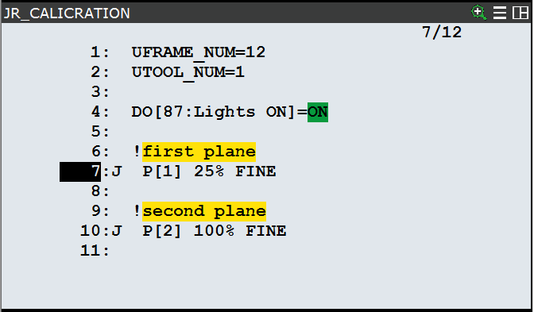
- MENU-8 (IRVISION)-F1(TYPE)-5(Vision Utilities)
- 2. Automatic grid frame set
- Go to line 8 and hold shift and hit F4 (record)
- Enter parameters in picture below (1-12)

!!THE CAMERA SHOULD ALREADY BE NAMED!!
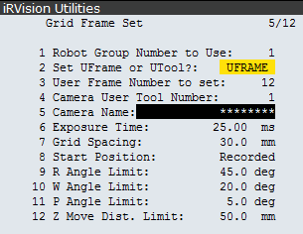
- Make sure you are not on line 8 and hold deadman and shift and hit F5(EXECUTE)
- After completion it will tell you if it was successful

